

SAFETY DATA SHEET
Jubilee Oven and Grill

SECTION 1: Identification: Product identifier and chemical identity

Product identifier
Product name Jubilee Oven and Grill
Internal identification JUBOVEN

Relevant identified uses of the substance or mixture and uses advised against Application High alkaline cleaner for ovens, grills and baking surfaces Uses advised against Use only for intended applications.

Details of the supplier of the safety data sheet
Supplier Sampson Chemical Products 42 Redcliffe Gardens Drive Clontarf, QLD, 4019
+61 7 3283 4511
sampson_office@bigpond.com
Contact Person Poisons Information 131126 or Brennan Stark 0428 835 855 Manufacturer Eco Pro Australia Pty Ltd
42 Redcliffe Gardens Drive, Clontarf, QLD, 4019
+61 7 3283 4511
sampson_office@bigpond.com

Emergency telephone number
Emergency telephone Poisons Information 131126 or Brennan Stark 0428 835 855
SECTION 2: Hazard(s) identification

Classification of the substance or mixture Physical hazards Not Classified
Health hazards Skin Corr. 1A - H314 Eye Dam. 1 - H318 Environmental hazards Not Classified

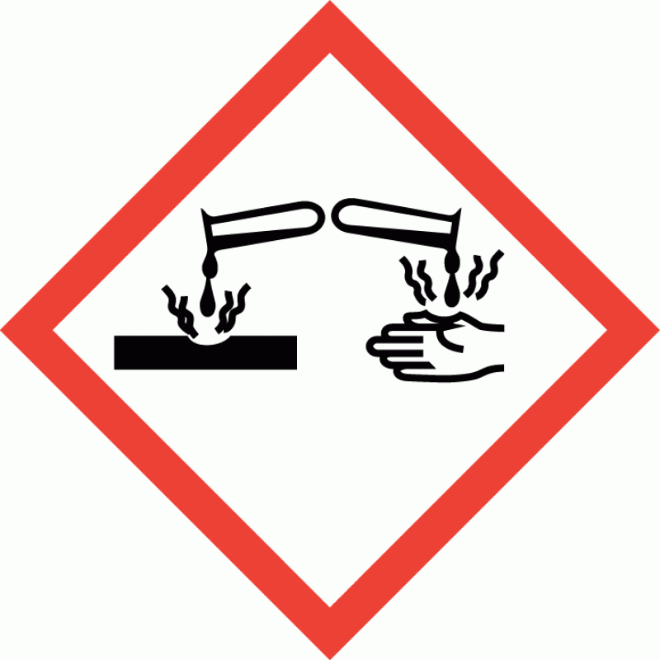
Label elements Hazard pictograms

Signal word DANGER
Hazard statements H314 Causes severe skin burns and eye damage.

Jubilee Oven and Grill

Precautionary statements P260 Do not breathe vapour/ spray.
P264 Wash contaminated skin thoroughly after handling.
P280 Wear protective gloves/ protective clothing/ eye protection/ face protection. P301+P330+P331 IF SWALLOWED: Rinse mouth. Do NOT induce vomiting.
P303+P361+P353 IF ON SKIN (or hair): Take off immediately all contaminated clothing. Rinse skin with water/ shower.
P304+P340 IF INHALED: Remove victim to fresh air and keep at rest in a position comfortable for breathing.
P305+P351+P338 IF IN EYES: Rinse cautiously with water for several minutes. Remove contact lenses, if present and easy to do. Continue rinsing.
P310 Immediately call a POISON CENTER or doctor/ physician. P321 Specific treatment (see medical advice on this label).
P363 Wash contaminated clothing before reuse. P405 Store locked up.
P501 Dispose of contents/ container in accordance with national regulations.
Contains Caustic Soda, Caustic Potash, Alkylpolyglycoside C8-10 Other hazards
This product does not contain any substances classified as PBT (persistent, bioaccumulative and toxic) or vPvB (very persistent and very bioaccumulative).

SECTION 3: Composition and information on ingredients
Mixtures
Caustic Soda  CAS number: 1310-73-2 | 10-30%
Caustic Potash  CAS number: 1310-58-3 | 1-10%
Alkylpolyglycoside C8-10 CAS number: 68515-73-1 | 1-10%
EDTA NA4  CAS number: 10378-23-1 | 1-10%
SECTION 4: First aid measures
Description of first aid measures
General information Get medical attention if any discomfort continues. Show this Safety Data Sheet to the medical personnel. Chemical burns must be treated by a physician.
Inhalation Move affected person to fresh air and keep warm and at rest in a position comfortable for breathing. Maintain an open airway. Loosen tight clothing such as collar, tie or belt. Rinse nose and mouth with water. Never give anything by mouth to an unconscious person. Get medical attention if symptoms are severe or persist.
Ingestion Rinse mouth thoroughly with water. Give a few small glasses of water or milk to drink. Stop if the affected person feels sick as vomiting may be dangerous. Get medical attention.
Skin Contact It is important to remove the substance from the skin immediately. Rinse immediately with plenty of water. Continue to rinse for at least 15 minutes and get medical attention. Chemical burns must be treated by a physician.

Jubilee Oven and Grill

Eye contact Rinse immediately with plenty of water. Do not rub eye. Remove any contact lenses and open eyelids wide apart. Continue to rinse for at least 15 minutes and get medical attention.
Protection of first aiders It may be dangerous for first aid personnel to carry out mouth-to-mouth resuscitation.

Most important symptoms and effects, both acute and delayed
General information The severity of the symptoms described will vary dependent on the concentration and the length of exposure.
Inhalation A single exposure may cause the following adverse effects: Corrosive to the respiratory tract.
Symptoms following overexposure may include the following: Severe irritation of nose and throat.
Ingestion May cause chemical burns in mouth, oesophagus and stomach. Symptoms following overexposure may include the following: Severe stomach pain. Nausea, vomiting.
Skin contact Causes severe burns. Symptoms following overexposure may include the following: Pain or irritation. Redness. Blistering may occur.
Eye contact Causes serious eye damage. Symptoms following overexposure may include the following: Pain. Profuse watering of the eyes. Redness.

Indication of any immediate medical attention and special treatment needed Notes for the doctor Treat symptomatically.
SECTION 5: Firefighting measures

Extinguishing media
Suitable extinguishing media The product is not flammable. Extinguish with alcohol-resistant foam, carbon dioxide, dry powder or water fog. Use fire-extinguishing media suitable for the surrounding fire.

Unsuitable extinguishing media
Do not use water jet as an extinguisher, as this will spread the fire.

Special hazards arising from the substance or mixture
Specific hazards Containers can burst violently or explode when heated, due to excessive pressure build-up.
Severe corrosive hazard. Water used for fire extinguishing, which has been in contact with the product, may be corrosive.

Hazardous combustion products
Advice for firefighters
Protective actions during firefighting

Special protective equipment for firefighters
Thermal decomposition or combustion products may include the following substances: Very toxic or corrosive gases or vapours.

Avoid breathing fire gases or vapours. Evacuate area. Keep upwind to avoid inhalation of gases, vapours, fumes and smoke. Cool containers exposed to heat with water spray and remove them from the fire area if it can be done without risk. Cool containers exposed to flames with water until well after the fire is out. If a leak or spill has not ignited, use water spray to disperse vapours and protect men stopping the leak. Avoid discharge to the aquatic environment. Control run-off water by containing and keeping it out of sewers and watercourses. If risk of water pollution occurs, notify appropriate authorities.
Regular protection may not be safe. Wear chemical protective suit. Wear positive-pressure self-contained breathing apparatus (SCBA) and appropriate protective clothing. Firefighter's clothing conforming to Australia/New Zealand Standards AS/NZS 4967 (for clothing) AS/NZS 1801 (for helmets), AS/NZS 4821 (for protective boots), AS/NZS 1801 (for protective gloves) will provide a basic level of protection for chemical incidents.

Hazchem Code 2X

Jubilee Oven and Grill
SECTION 6: Accidental release measures

Personal precautions, protective equipment and emergency procedures
Personal precautions Wear protective clothing as described in Section 8 of this safety data sheet. No action shall be taken without appropriate training or involving any personal risk. Avoid inhalation of dust and vapours. Use suitable respiratory protection if ventilation is inadequate. Avoid contact with skin and eyes.

Environmental precautions
Environmental precautions The product may affect the acidity (pH) of water which may have hazardous effects on aquatic organisms. Avoid discharge to the aquatic environment.

Methods and material for containment and cleaning up
Methods for cleaning up Wear protective clothing as described in Section 8 of this safety data sheet. Clear up spills immediately and dispose of waste safely. This product is corrosive. Small Spillages: Collect spillage. Large Spillages: Absorb spillage with non-combustible, absorbent material. The contaminated absorbent may pose the same hazard as the spilled material. Collect and place in suitable waste disposal containers and seal securely. Label the containers containing waste and contaminated materials and remove from the area as soon as possible. Flush contaminated area with plenty of water. Wash thoroughly after dealing with a spillage. For waste disposal, see Section 13.

Reference to other sections
Reference to other sections For personal protection, see Section 8. See Section 11 for additional information on health hazards. See Section 12 for additional information on ecological hazards. For waste disposal, see Section 13.
SECTION 7: Handling and storage, including how the chemical may be safely used

Precautions for safe handling
Usage precautions Read and follow manufacturer's recommendations. Wear protective clothing as described in Section 8 of this safety data sheet. Keep away from food, drink and animal feeding stuffs.
Handle all packages and containers carefully to minimise spills. Keep container tightly sealed when not in use. Avoid the formation of mists. This product is corrosive. Immediate first aid is imperative. Do not handle until all safety precautions have been read and understood. Do not handle broken packages without protective equipment. Do not reuse empty containers.

Advice on general occupational hygiene
Wash promptly if skin becomes contaminated. Take off contaminated clothing and wash before reuse. Wash contaminated clothing before reuse.

Conditions for safe storage, including any incompatibilities
Storage precautions Store locked up. Keep only in the original container. Keep container tightly closed, in a cool, well ventilated place. Keep containers upright. Protect containers from damage. Store away from incompatible materials (see Section 10).
Storage class Corrosive storage.

Specific end use(s)
Specific end use(s) The identified uses for this product are detailed in Section 1.
SECTION 8: Exposure controls and personal protection

Control parameters Occupational exposure limits Caustic Soda
Ceiling value: 2 mg/m³

Jubilee Oven and Grill

Caustic Potash Ceiling value: 2 mg/m³







Exposure controls Protective equipment

Appropriate engineering controls
Provide adequate ventilation. Observe any occupational exposure limits for the product or ingredients.

Eye/face protection Wear tight-fitting, chemical splash goggles or face shield. If inhalation hazards exist, a full-face respirator may be required instead.
Hand protection Wear protective gloves. The most suitable glove should be chosen in consultation with the glove supplier/manufacturer, who can provide information about the breakthrough time of the glove material. To protect hands from chemicals, gloves should comply with Australia/New Zealand Standard AS/NZS 2161. Considering the data specified by the glove manufacturer, check during use that the gloves are retaining their protective properties and change them as soon as any deterioration is detected. Frequent changes are recommended.

Other skin and body protection
Wear appropriate clothing to prevent any possibility of skin contact.

Hygiene measures Wash hands thoroughly after handling. Wash at the end of each work shift and before eating, smoking and using the toilet. Do not eat, drink or smoke when using this product.
Respiratory protection Ensure all respiratory protective equipment is suitable for its intended use and complies with Australia/New Zealand Standard AS/NZS 1716. Check that the respirator fits tightly and the filter is changed regularly. Gas and combination filter cartridges should comply with Australia/New Zealand Standard AS/NZS 1716. Full face mask respirators with replaceable filter cartridges should comply with Australia/New Zealand Standard AS/NZS 1716. Half mask and quarter mask respirators with replaceable filter cartridges should comply with Australia/New Zealand Standard AS/NZS 1716.

Environmental exposure controls
Keep container tightly sealed when not in use. Emissions from ventilation or work process equipment should be checked to ensure they comply with the requirements of environmental protection legislation. In some cases, fume scrubbers, filters or engineering modifications to the process equipment will be necessary to reduce emissions to acceptable levels.

SECTION 9: Physical and chemical properties

Information on basic physical and chemical properties Appearance Coloured liquid.
Colour Dark brown.
Odour Typical chemical odour
pH 14
Specific Gravity 1.12
Solubility(ies) Soluble in water.
SECTION 10: Stability and reactivity
Reactivity There are no known reactivity hazards associated with this product.

Jubilee Oven and Grill

Stability Stable at normal ambient temperatures and when used as recommended. Stable under the prescribed storage conditions.

Possibility of hazardous reactions
No potentially hazardous reactions known.

Conditions to avoid Avoid heat, flames and other sources of ignition.

Materials to avoid Reacts violently with acids in an exothermic reaction. Reacts with oxidising agents. May be corrosive to metals.

Hazardous decomposition products
Does not decompose when used and stored as recommended. Thermal decomposition or combustion products may include the following substances: Corrosive gases or vapours.

SECTION 11: Toxicological information

Information on toxicological effects Acute toxicity - oral
Notes (oral LD₅₀) Based on available data the classification criteria are not met.

ATE oral (mg/kg) 24,600.0 Acute toxicity - dermal
Notes (dermal LD₅₀) Based on available data the classification criteria are not met.

Acute toxicity - inhalation
Notes (inhalation LC₅₀) Based on available data the classification criteria are not met.

Skin corrosion/irritation
Animal data Skin Corr. 1A - H314 Causes severe burns.

Serious eye damage/irritation
Serious eye damage/irritation Eye Dam. 1 - H318 Corrosive to skin. Corrosivity to eyes is assumed.

Respiratory sensitisation
Respiratory sensitisation Based on available data the classification criteria are not met.

Skin sensitisation
Skin sensitisation Based on available data the classification criteria are not met.

Germ cell mutagenicity
Genotoxicity - in vitro Based on available data the classification criteria are not met.

Carcinogenicity
Carcinogenicity Based on available data the classification criteria are not met. IARC carcinogenicity None of the ingredients are listed or exempt.

Reproductive toxicity
Reproductive toxicity - fertility Based on available data the classification criteria are not met.

Reproductive toxicity - development
Based on available data the classification criteria are not met.

Specific target organ toxicity - single exposure
STOT - single exposure Not classified as a specific target organ toxicant after a single exposure.

Specific target organ toxicity - repeated exposure
STOT - repeated exposure Not classified as a specific target organ toxicant after repeated exposure.

Jubilee Oven and Grill

Aspiration hazard
Aspiration hazard Based on available data the classification criteria are not met.

General information The severity of the symptoms described will vary dependent on the concentration and the length of exposure.
Inhalation Corrosive to the respiratory tract. Symptoms following overexposure may include the following: Severe irritation of nose and throat.
Ingestion May cause chemical burns in mouth, oesophagus and stomach. Symptoms following overexposure may include the following: Severe stomach pain. Nausea, vomiting.
Skin Contact Causes severe burns. Symptoms following overexposure may include the following: Pain or irritation. Redness. Blistering may occur.
Eye contact Causes serious eye damage. Symptoms following overexposure may include the following: Pain. Profuse watering of the eyes. Redness.
Route of exposure Ingestion Inhalation Skin and/or eye contact Target Organs No specific target organs known.
SECTION 12: Ecological information

Ecotoxicity Not regarded as dangerous for the environment. However, large or frequent spills may have hazardous effects on the environment.
Toxicity Based on available data the classification criteria are not met. Persistence and degradability
Persistence and degradability The degradability of the product is not known.

Bioaccumulative potential
Bioaccumulative Potential No data available on bioaccumulation.

Mobility in soil
Mobility No data available.

Other adverse effects
Other adverse effects None known.
SECTION 13: Disposal considerations

Waste treatment methods
General information The generation of waste should be minimised or avoided wherever possible. Reuse or recycle products wherever possible. This material and its container must be disposed of in a safe way. When handling waste, the safety precautions applying to handling of the product should be considered. Care should be taken when handling emptied containers that have not been thoroughly cleaned or rinsed out. Empty containers or liners may retain some product residues and hence be potentially hazardous.
Disposal methods Dispose of surplus products and those that cannot be recycled via a licensed waste disposal contractor. Waste, residues, empty containers, discarded work clothes and contaminated cleaning materials should be collected in designated containers, labelled with their contents. Incineration or landfill should only be considered when recycling is not feasible.
SECTION 14: Transport information

Jubilee Oven and Grill

UN number
UN No. (ADG) 1760
UN No. (IMDG) 1760
UN No. (ICAO) 1760
UN proper shipping name
Proper shipping name (ADG) CORROSIVE LIQUID, N.O.S. (CONTAINS Caustic Soda, Caustic Potash)

Proper shipping name (IMDG)
CORROSIVE LIQUID, N.O.S. (CONTAINS Caustic Soda, Caustic Potash)

Proper shipping name (ICAO) CORROSIVE LIQUID, N.O.S. (CONTAINS Caustic Soda, Caustic Potash)

Transport hazard class(es)
ADG class 8
ADG classification code C9
ADG label 8
IMDG class 8
ICAO class/division 8

Transport labels
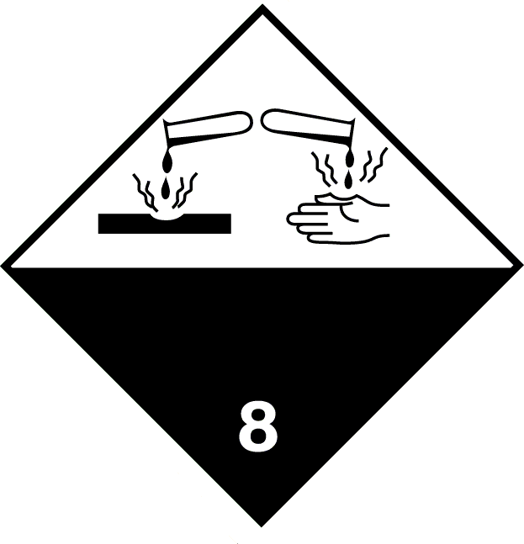

Packing group
ADG packing group II
IMDG packing group II
ICAO packing group II

Environmental hazards
Environmentally hazardous substance/marine pollutant No.
Special precautions for user
EmS F-A, S-B

Hazchem Code 2X

Transport in bulk according to Annex II of MARPOL 73/78 and the IBC Code
Not applicable.

SECTION 15: Regulatory information

Inventories Australia - AICS
None of the ingredients are listed or exempt.
SECTION 16: Any other relevant information

Jubilee Oven and Grill

Training advice Only trained personnel should use this material.
Revision date 29/01/2026

Revision 4
Supersedes date 27/07/2021
SDS No. 4800
General Information The following risk and hazard statements are to be considered a glossary. They relate to the raw materials used in this product and therefore may not be accurate for the finished product itself. For the complete risk and hazard statements for this product please refer to section 2 of this Safety Data Sheet
Hazard statements in full H314 Causes severe skin burns and eye damage.
H318 Causes serious eye damage.

This information relates only to the specific material designated and may not be valid for such material used in combination with any other materials or in any process. Such information is, to the best of the company's knowledge and belief, accurate and reliable as of the date indicated. However, no warranty, guarantee or representation is made to its accuracy, reliability or completeness. It is the user's responsibility to satisfy himself as to the suitability of such information for his own particular use.

