

SAFETY DATA SHEET
Deo Blocks

SECTION 1: Identification: Product identifier and chemical identity

Product identifier
Product name Deo Blocks
Internal identification DEOBLOCKLAV Synonyms; trade names p-dichlorobenzene CAS number 106-46-7
Relevant identified uses of the substance or mixture and uses advised against Application Air freshener, toilet freshener, deodorant block Uses advised against Use only for intended applications.

Details of the supplier of the safety data sheet
Supplier Sampson Chemical Products 42 Redcliffe Gardens Drive Clontarf, QLD, 4019
+61 7 3283 4511
sampson_office@bigpond.com
Contact Person Poisons Information 131126 or Brennan Stark 0428 835 855 Manufacturer Eco Pro Australia Pty Ltd
42 Redcliffe Gardens Drive, Clontarf, QLD, 4019
+61 7 3283 4511
sampson_office@bigpond.com

Emergency telephone number
Emergency telephone Poisons Information 131126 or Brennan Stark 0428 835 855
SECTION 2: Hazard(s) identification

Classification of the substance or mixture Physical hazards Not Classified
Health hazards Eye Irrit. 2A - H319 Carc. 2 - H351 Environmental hazards Aquatic Acute 1 - H400 Aquatic Chronic 1 - H410


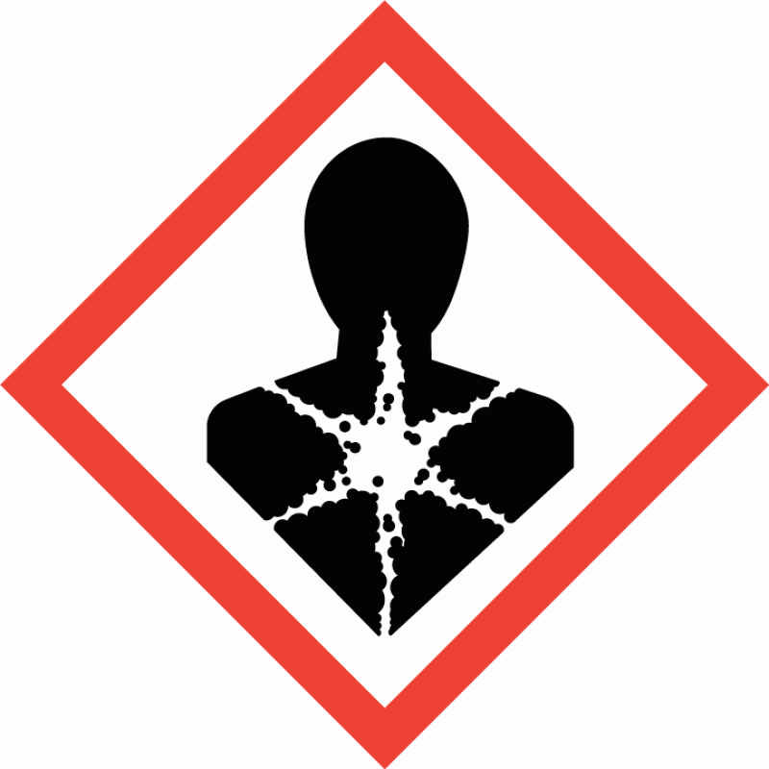
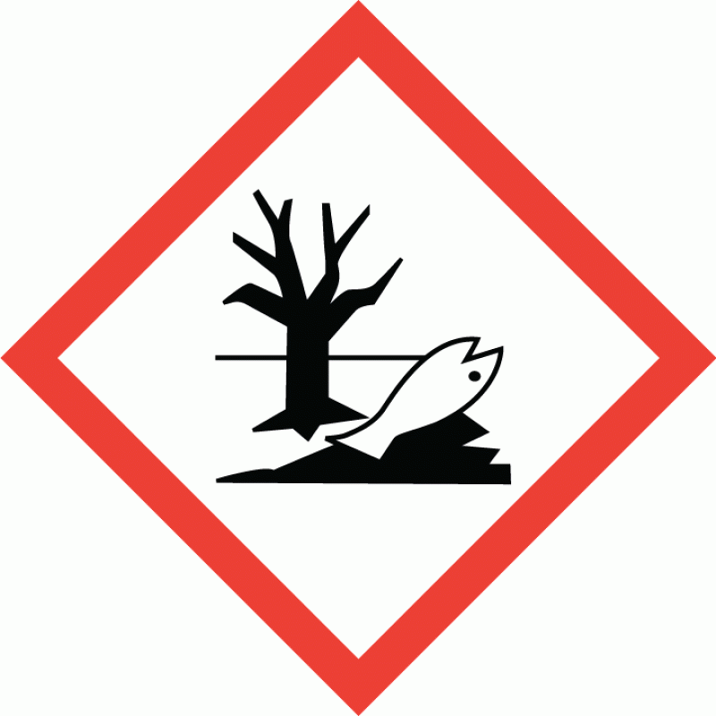
Label elements Hazard pictograms

Signal word WARNING

Deo Blocks

Hazard statements H319 Causes serious eye irritation.
H351 Suspected of causing cancer.
H410 Very toxic to aquatic life with long lasting effects.
Precautionary statements P201 Obtain special instructions before use.
P202 Do not handle until all safety precautions have been read and understood. P264 Wash contaminated skin thoroughly after handling.
P273 Avoid release to the environment.
P280 Wear protective gloves/ protective clothing/ eye protection/ face protection. P305+P351+P338 IF IN EYES: Rinse cautiously with water for several minutes. Remove contact lenses, if present and easy to do. Continue rinsing.
P308+P313 IF exposed or concerned: Get medical advice/ attention. P337+P313 If eye irritation persists: Get medical advice/ attention. P391 Collect spillage.
P405 Store locked up.
P501 Dispose of contents/ container in accordance with national regulations.
Contains 1,4-dichlorobenzene Other hazards
This product does not contain any substances classified as PBT (persistent, bioaccumulative and toxic) or vPvB (very persistent and very bioaccumulative).
SECTION 3: Composition and information on ingredients

Mixtures
1,4-dichlorobenzene
CAS number: 106-46-7
>60%
SECTION 4: First aid measures

Description of first aid measures
General information Get medical attention if any discomfort continues. Show this Safety Data Sheet to the medical personnel.
Inhalation Move affected person to fresh air and keep warm and at rest in a position comfortable for breathing. Loosen tight clothing such as collar, tie or belt. Get medical attention if symptoms are severe or persist.
Ingestion Rinse mouth thoroughly with water. Get medical advice/attention if you feel unwell. Do not induce vomiting unless under the direction of medical personnel.
Skin Contact Rinse with water.
Eye contact Rinse with water. Do not rub eye. Remove any contact lenses and open eyelids wide apart.
Get medical attention if any discomfort continues.
Protection of first aiders First aid personnel should wear appropriate protective equipment during any rescue. Most important symptoms and effects, both acute and delayed
General information The severity of the symptoms described will vary dependent on the concentration and the length of exposure.
Inhalation Prolonged or repeated exposure may cause the following adverse effects: Suspected of causing cancer.
Ingestion Prolonged or repeated exposure may cause the following adverse effects: Suspected of causing cancer.

Deo Blocks

Skin contact Prolonged contact may cause dryness of the skin. Prolonged or repeated exposure may cause the following adverse effects: Suspected of causing cancer.
Eye contact Irritating to eyes.

Indication of any immediate medical attention and special treatment needed Notes for the doctor Treat symptomatically.
SECTION 5: Firefighting measures
Extinguishing media
Suitable extinguishing media The product is not flammable. Extinguish with alcohol-resistant foam, carbon dioxide, dry powder or water fog. Use fire-extinguishing media suitable for the surrounding fire.

Unsuitable extinguishing media
Do not use water jet as an extinguisher, as this will spread the fire.

Special hazards arising from the substance or mixture Specific hazards None known.

Hazardous combustion products
Advice for firefighters
Protective actions during firefighting

Special protective equipment for firefighters
Thermal decomposition or combustion products may include the following substances: Harmful gases or vapours.

Avoid breathing fire gases or vapours. Evacuate area. Keep upwind to avoid inhalation of gases, vapours, fumes and smoke. Ventilate closed spaces before entering them. Cool containers exposed to heat with water spray and remove them from the fire area if it can be done without risk. Cool containers exposed to flames with water until well after the fire is out. Avoid discharge to the aquatic environment. Control run-off water by containing and keeping it out of sewers and watercourses. If risk of water pollution occurs, notify appropriate authorities.
Wear positive-pressure self-contained breathing apparatus (SCBA) and appropriate protective clothing. Firefighter's clothing conforming to Australia/New Zealand Standards AS/NZS 4967 (for clothing) AS/NZS 1801 (for helmets), AS/NZS 4821 (for protective boots), AS/NZS 1801 (for protective gloves) will provide a basic level of protection for chemical incidents.

Hazchem Code 2Z
SECTION 6: Accidental release measures

Personal precautions, protective equipment and emergency procedures
Personal precautions Wear protective clothing as described in Section 8 of this safety data sheet. No action shall be taken without appropriate training or involving any personal risk.

Environmental precautions
Environmental precautions Avoid discharge into drains or watercourses or onto the ground. Avoid discharge to the aquatic environment.

Methods and material for containment and cleaning up
Methods for cleaning up Wear protective clothing as described in Section 8 of this safety data sheet. Clear up spills immediately and dispose of waste safely. Collect spillage with a shovel and broom, or similar and reuse, if possible. Collect and place in suitable waste disposal containers and seal securely. Flush contaminated area with plenty of water. Wash thoroughly after dealing with a spillage. Dangerous for the environment. Do not empty into drains. For waste disposal, see Section 13.
Reference to other sections

Deo Blocks

Reference to other sections For personal protection, see Section 8. See Section 11 for additional information on health hazards. See Section 12 for additional information on ecological hazards. For waste disposal, see Section 13.
SECTION 7: Handling and storage, including how the chemical may be safely used

Precautions for safe handling
Usage precautions Read and follow manufacturer's recommendations. Wear protective clothing as described in Section 8 of this safety data sheet. Keep away from food, drink and animal feeding stuffs.
Keep container tightly sealed when not in use. Suspected of causing cancer. Avoid discharge to the aquatic environment. Do not handle until all safety precautions have been read and understood. Do not handle broken packages without protective equipment. Do not reuse empty containers.

Advice on general occupational hygiene
Wash promptly if skin becomes contaminated. Take off contaminated clothing and wash before reuse. Wash contaminated clothing before reuse.

Conditions for safe storage, including any incompatibilities
Storage precautions Store locked up. Keep only in the original container. Keep container tightly closed, in a cool, well ventilated place. Keep containers upright. Protect containers from damage.
Storage class Miscellaneous hazardous material storage.

Specific end use(s)
Specific end use(s) The identified uses for this product are detailed in Section 1.
SECTION 8: Exposure controls and personal protection

Control parameters Occupational exposure limits
Long-term exposure limit (8-hour TWA): 25 ppm 150 mg/m³
Short-term exposure limit (15-minute): 50 ppm 300 mg/m³ Carc. 2

1,4-dichlorobenzene
Long-term exposure limit (8-hour TWA): 25 ppm 150 mg/m³ Short-term exposure limit (15-minute): 50 ppm 300 mg/m³ Carc. 2
Carc. 2 = Suspected human carcinogen.



Exposure controls Protective equipment

Appropriate engineering controls
Provide adequate general and local exhaust ventilation. Ensure the ventilation system is regularly maintained and tested. Good general ventilation should be adequate to control worker exposure to airborne contaminants. Observe any occupational exposure limits for the product or ingredients.

Eye/face protection Wear tight-fitting, chemical splash goggles or face shield. If inhalation hazards exist, a full-face respirator may be required instead.
Hand protection No specific hand protection recommended. Avoid contact with skin.

Other skin and body protection
Wear appropriate clothing to prevent repeated or prolonged skin contact.

Deo Blocks

Hygiene measures Wash hands thoroughly after handling. Wash at the end of each work shift and before eating, smoking and using the toilet. Do not eat, drink or smoke when using this product.
Respiratory protection Ensure all respiratory protective equipment is suitable for its intended use and complies with Australia/New Zealand Standard AS/NZS 1716. Check that the respirator fits tightly and the filter is changed regularly. Gas and combination filter cartridges should comply with Australia/New Zealand Standard AS/NZS 1716. Full face mask respirators with replaceable filter cartridges should comply with Australia/New Zealand Standard AS/NZS 1716. Half mask and quarter mask respirators with replaceable filter cartridges should comply with Australia/New Zealand Standard AS/NZS 1716.

Environmental exposure controls
Keep container tightly sealed when not in use. Emissions from ventilation or work process equipment should be checked to ensure they comply with the requirements of environmental protection legislation. In some cases, fume scrubbers, filters or engineering modifications to the process equipment will be necessary to reduce emissions to acceptable levels.

SECTION 9: Physical and chemical properties
Information on basic physical and chemical properties Appearance Crystalline solid.
Colour Lavender
Odour Characteristic.
Specific Gravity 1.46
Melting point 53°C

Initial boiling point and range 173°C
Flash point 65°C Closed cup. Auto-ignition temperature 413°C

Volatile By Vol. (%) 100
SECTION 10: Stability and reactivity
Reactivity There are no known reactivity hazards associated with this product.
Stability Stable at normal ambient temperatures and when used as recommended. Stable under the prescribed storage conditions.

Possibility of hazardous reactions
No potentially hazardous reactions known.

Conditions to avoid Avoid heat, flames and other sources of ignition. Materials to avoid Strong oxidising agents. Alkalis.

Hazardous decomposition products
SECTION 11: Toxicological information
Burning can produce carbon monoxide and/or carbon dioxide, hydrogen chloride and phosgene.

Information on toxicological effects Acute toxicity - oral
Notes (oral LD₅₀) Based on available data the classification criteria are not met.

Deo Blocks

Acute toxicity - dermal
Notes (dermal LD₅₀) Based on available data the classification criteria are not met.

Acute toxicity - inhalation
Notes (inhalation LC₅₀) Based on available data the classification criteria are not met.

Skin corrosion/irritation
Animal data Based on available data the classification criteria are not met.

Serious eye damage/irritation
Serious eye damage/irritation Causes serious eye irritation.

Respiratory sensitisation
Respiratory sensitisation Based on available data the classification criteria are not met.

Skin sensitisation
Skin sensitisation Based on available data the classification criteria are not met.

Germ cell mutagenicity
Genotoxicity - in vitro Based on available data the classification criteria are not met.

Carcinogenicity
Carcinogenicity Suspected of causing cancer.
IARC carcinogenicity None of the ingredients are listed or exempt. Reproductive toxicity
Reproductive toxicity - fertility Based on available data the classification criteria are not met.

Reproductive toxicity - development
Based on available data the classification criteria are not met.

Specific target organ toxicity - single exposure
STOT - single exposure Not classified as a specific target organ toxicant after a single exposure.

Specific target organ toxicity - repeated exposure
STOT - repeated exposure Not classified as a specific target organ toxicant after repeated exposure.

Aspiration hazard
Aspiration hazard Not relevant. Solid.

General information May cause cancer after repeated exposure. Risk of cancer depends on duration and level of exposure. The severity of the symptoms described will vary dependent on the concentration and the length of exposure.
Inhalation No specific symptoms known.
Ingestion No specific symptoms known.
Skin Contact Prolonged contact may cause dryness of the skin.
Eye contact Irritating to eyes.
Route of exposure Ingestion Inhalation Skin and/or eye contact Target Organs No specific target organs known.
SECTION 12: Ecological information

Deo Blocks

Toxicity Aquatic Acute 1 - H400 Very toxic to aquatic life. Aquatic Chronic 1 - H410 Very toxic to aquatic life with long lasting effects.

Persistence and degradability
Persistence and degradability The degradability of the product is not known.

Bioaccumulative potential
Bioaccumulative Potential Bioaccumulation is unlikely to be significant because of the low water-solubility of this product.

Mobility in soil
Mobility Immiscible with water

Other adverse effects
Other adverse effects None known.
SECTION 13: Disposal considerations

Waste treatment methods
General information The generation of waste should be minimised or avoided wherever possible. Reuse or recycle products wherever possible. This material and its container must be disposed of in a safe way. When handling waste, the safety precautions applying to handling of the product should be considered. Care should be taken when handling emptied containers that have not been thoroughly cleaned or rinsed out. Empty containers or liners may retain some product residues and hence be potentially hazardous.
Disposal methods Dispose of surplus products and those that cannot be recycled via a licensed waste disposal contractor. Waste, residues, empty containers, discarded work clothes and contaminated cleaning materials should be collected in designated containers, labelled with their contents. Incineration or landfill should only be considered when recycling is not feasible.
SECTION 14: Transport information

UN number
UN No. (ADG) 3077
UN No. (IMDG) 3077
UN No. (ICAO) 3077

UN proper shipping name
Proper shipping name (ADG) ENVIRONMENTALLY HAZARDOUS SUBSTANCE, SOLID, N.O.S. (CONTAINS 1,4-
dichlorobenzene)

Proper shipping name (IMDG)
ENVIRONMENTALLY HAZARDOUS SUBSTANCE, SOLID, N.O.S. (CONTAINS 1,4-
dichlorobenzene)

Proper shipping name (ICAO) ENVIRONMENTALLY HAZARDOUS SUBSTANCE, SOLID, N.O.S. (CONTAINS 1,4-
dichlorobenzene)

Transport hazard class(es)

ADG class 9

ADG classification code M7

ADG label 9

IMDG class 9

ICAO class/division 9

Deo Blocks

Transport labels

Packing group

ADG packing group III

IMDG packing group III

ICAO packing group III

Environmental hazards


Environmentally hazardous substance/marine pollutant

Special precautions for user
EmS F-A, S-F

Hazchem Code 2Z

Transport in bulk according to Annex II of MARPOL 73/78 and the IBC Code
Not applicable.

SECTION 15: Regulatory information

Inventories Australia - AICS
None of the ingredients are listed or exempt.
SECTION 16: Any other relevant information

Training advice Only trained personnel should use this material.
Revision date 22/01/2026

Revision 4
Supersedes date 20/09/2022
SDS No. 4611
General Information The following risk and hazard statements are to be considered a glossary. They relate to the raw materials used in this product and therefore may not be accurate for the finished product itself. For the complete risk and hazard statements for this product please refer to section 2 of this Safety Data Sheet
Hazard statements in full H319 Causes serious eye irritation.
H351 Suspected of causing cancer. H400 Very toxic to aquatic life.
H410 Very toxic to aquatic life with long lasting effects.

This information relates only to the specific material designated and may not be valid for such material used in combination with any other materials or in any process. Such information is, to the best of the company's knowledge and belief, accurate and reliable as of the date indicated. However, no warranty, guarantee or representation is made to its accuracy, reliability or completeness. It is the user's responsibility to satisfy himself as to the suitability of such information for his own particular use.

